update() method

update() method of model manager is used to update or replace values of model.

Syntax:
model-name.objects.filter(condition).update(fieldname=value)

This method is used to update one or more than one record

In Django, an F() object represents the value of a model field or an annotated column within a database query. Its primary purpose is to allow the database, rather than Python, to perform operations on field values.
F object is exists django.models.db.F

>>> from app2.models import Employee
>>> Employee.objects.filter(job='clerk').update(salary=12000)
3
>>> Employee.objects.filter(job='hr').update(salary=salary+5000)
Traceback (most recent call last):
File "<console>", line 1, in <module>
NameError: name 'salary' is not defined
>>> from django.db.models import F
>>> Employee.objects.filter(job='hr').update(salary=F('salary')+5000)
2
>>>
>>> Employee.objects.filter(empno=2).update(job='manager',salary=45000)
1
>>>

Update method of model manager, after updating records or rows it returns update count.

>>> Employee.objects.filter(empno=100).update(job='manager',salary=45000)
0
>>>

delete() method

delete() method of model manager deletes one or more than one row.

Syntax:
model-name.objects.filter(condition).delete()
model-name.objects.get(condition).delete()

delete() method can applited on model instance or query set.

>>> emp=Employee.objects.get(empno=5)
>>> print(emp.empno,emp.ename,emp.job,emp.salary,emp.deptno)
5 rajesh hr 33000.0 20
>>> emp.delete()
(1, {'app2.Employee': 1})
>>> Employee.objects.get(empno=5)
Traceback (most recent call last):
File "<console>", line 1, in <module>
File "C:\Users\Satish Gupta\AppData\Local\Programs\Python\Python312\Lib\site-packages\django\db\models\manager.py", line 87, in manager_method
return getattr(self.get_queryset(), name)(*args, **kwargs)
^^^^^^^^^^^^^^^^^^^^^^^^^^^^^^^^^^^^^^^^^^^^^^^^^^^
File "C:\Users\Satish Gupta\AppData\Local\Programs\Python\Python312\Lib\site-packages\django\db\models\query.py", line 639, in get
raise self.model.DoesNotExist(
app2.models.Employee.DoesNotExist: Employee matching query does not exist.
>>>
>>> t=Employee.objects.filter(job='clerk').delete()
>>> print(t)
(3, {'app2.Employee': 3})
>>>
>>> t=Employee.objects.filter(job='clerk').delete()
>>> print(t)
(0, {})
>>>

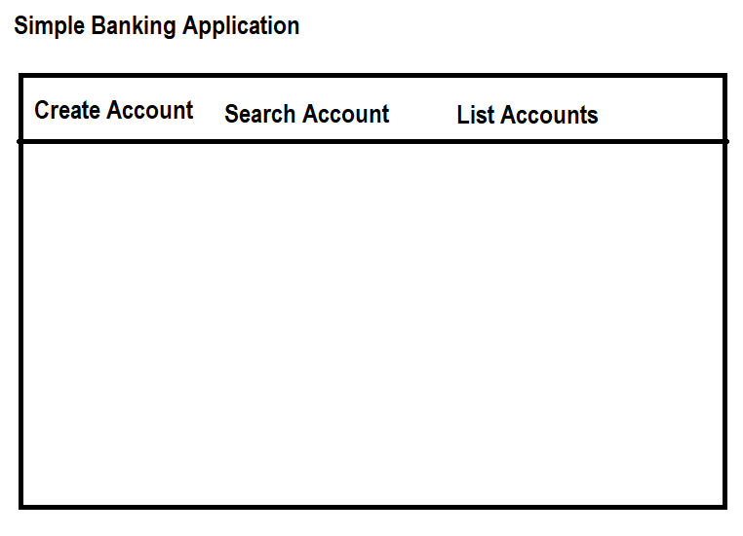

mysql> create database database11;
Query OK, 1 row affected (0.03 sec)

PS D:\Backup\Django9amMar> django-admin startproject bankproj
PS D:\Backup\Django9amMar> cd bankproj
PS D:\Backup\Django9amMar\bankproj> python manage.py startapp bankapp
PS D:\Backup\Django9amMar\bankproj>

models.py

from django.db import models

# Create your models here.
class Account(models.Model):
accno=models.AutoField(primary_key=True)
cname=models.CharField(max_length=20)
acctype=models.CharField(max_length=15)
balance=models.FloatField()

settings.py

INSTALLED_APPS = [
'django.contrib.admin',
'django.contrib.auth',
'django.contrib.contenttypes',
'django.contrib.sessions',
'django.contrib.messages',
'django.contrib.staticfiles',
'bankapp',
]
TEMPLATES = [
{
'BACKEND': 'django.template.backends.django.DjangoTemplates',
'DIRS': [BASE_DIR/"templates"],
DATABASES = {
'default': {
'ENGINE': 'django.db.backends.mysql',
'NAME': 'database11',
'USER':'root',
'PASSWORD':'root',
'HOST':'localhost',
'PORT':'3306'
}
}

PS D:\Backup\Django9amMar\bankproj> python manage.py makemigrations
PS D:\Backup\Django9amMar\bankproj> python manage.py migrate

